Minutes from the TIE Project meeting in Paris, the 3rd of April 2019

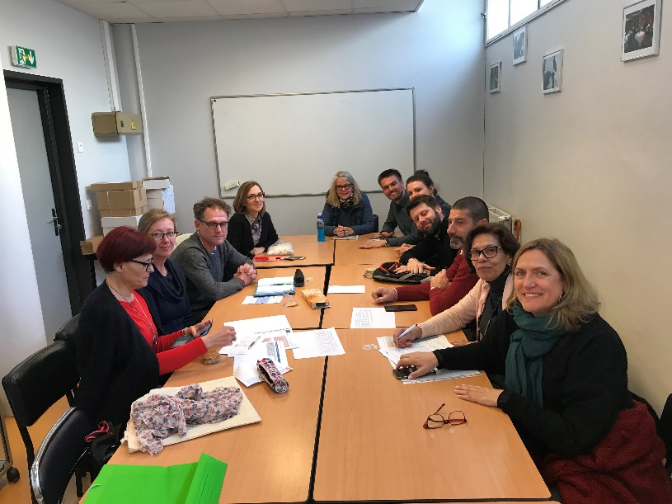
- Website. The website that Sirry is working on is coming along well. Every participant has to make sure that everything regarding each mobility such as pictures, presentations and projects are sent to Sirry and added to the site.
- Etwinning. Everyone needs to look at the Etwinning site as well. Adil will work on that.
- Budget. The project is on budget. There is a talk about the importance of invoices in case there is an audit. Bertha also tells the meeting that the national agency advises that money should not be forwarded to participants unless they are using it.
- Interrim report. Bertha expects to submit it in September. She will write to everyone regarding that.
- Evaluation. We are doing well. It is however important to upload all the products onto the Erasmus platform. We have to make sure that we have something tangible to show such as posters, infographs etc. Links to further evalutions regarding mobilities will be added to Whatsapp.
- Gaia mobility. Team Gaia and everyone else will think about the workshops that will take place in Portugal. Before arriving the student groups from each country should prepare a presentation on digital marketing in the 21st century and the psychology of social media. Each participant can approach the subject in its own way but everyone agreed that we would like to encourage the students to think critically about it.
- Expenses. Bertha and Adil agreed to look into options regarding the expenses of the Turkish delegation that missed the first mobility in Iceland.

